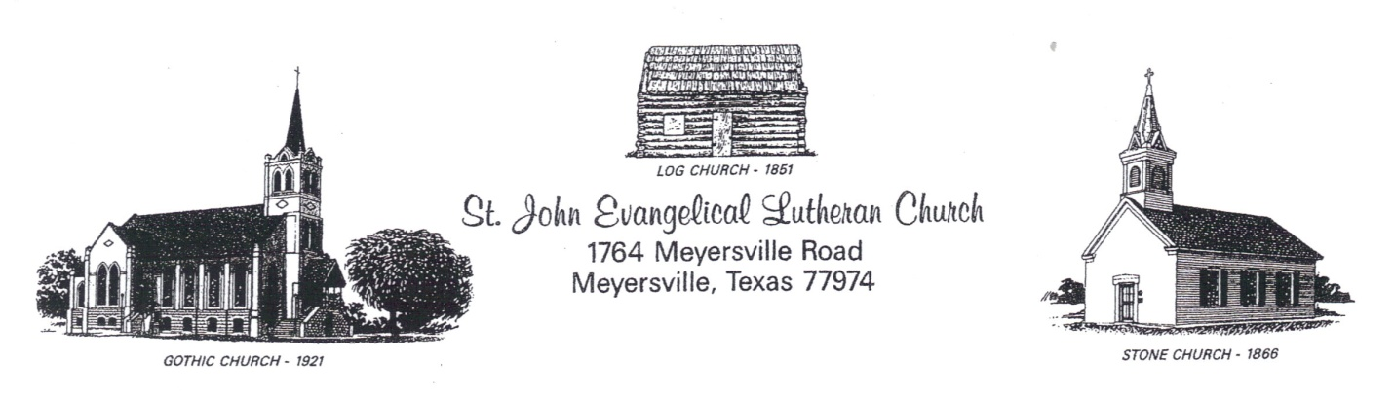

PROCEDURES FOR RETURNING TO WORSHIP IN THE ST. JOHN SANCTUARY
“For everything there is a season, and a time for every matter under heaven” (Ecclesiastes 3:1)
St.John Council and Worship Team have decided that worship services will resume in the sanctuary on June 7, 2020. HOWEVER, we want to do it safely—following the civil authorities’ guidelines as well as respecting the safety of all who want to return to worshiping here in our church. Here are the PRECAUTIONS that will be put in place:
- If you are not feeling well, please stay home. If you have read through this guidelines and do not feel comfortable coming back into the Sanctuary at this time, you are still welcome to listen to the radio broadcast in the parking lot at 101.5 FM or view the recorded service on our website: stjohnmeyersville.org. Bulletins are available on the website.
- Please respect other people. Everyone has a wide range of viewpoints, opinions and experiences with the pandemic and are handling in many different ways. We can love one another as Christian brothers and sisters even when we disagree. As long as we respect our fellow members need to be here and we remember the reason we are attending church. We are striving to meet all attendee’s expectations for holding service in the sanctuary and or open to input on how we can make the experience better for everyone.
- Facemasks are highly recommended. Remember you can have a few or no symptoms and still be contagious to someone who will be unable to tolerate the disease as well as you can. The use of facemasks are not intended to keep the user safe, but to keep other people around you safe. Let us strive to do this by taking the actions necessary to protect our fellow brothers and sisters even if it feels uncomfortable or strange. Please bring your own facemask, but if you do not have one, we will have some available at the entrances to the sanctuary.
- Hand sanitizer will be distributed at each entrance of the church. Put out your hand and a volunteer will dispense hand sanitizer into your hand as you enter the sanctuary.
- Every other pew has been marked “RESERVED”. Please pick an available pew. Households may sit together; otherwise, keep at least six feet of space between you any non-family or household member. Should we be so blessed as to fill the pews of the sanctuary to capacity we may need to have some remain in their vehicles and take part in the service as we will continue to broadcast the service in the parking lot.
- Offering plates will not be passed through the pews. They will be left as the ENTRANCES of the church. You will be able to leave your offering upon entering or leaving the church. It will be collected after the service.
- On communion Sundays ATTENDANCE CARDS may be dropped in the offering plates in the back of the church as you leave the sanctuary.
- HOLY COMMUNION will be continuous, station type of communion using individual cups. As we have always done you will come forward at the instruction of the usher. We will strive to maintain a safe 6-foot social distance as we come to communion. Pastor John will wash his hands with sanitizer in preparation for serving the host as he always has done. He will drop the wafer into each attendee’s out stretched hand without making contact. Please do not reach for the wafer as contact will necessitate Pastor John needing to re-sanitizing his hands. Communion assistants will wear masks and gloves as they set the individual cups on a stand one at a time for you to take as you pass by the station. As always during station communion, drop the used cup in the basket as you return to your seat, trying to maintain a safe distance between yourself and non-family members. If you are taking part in the service in your vehicle listening to the broadcast and you want to take communion, park on the west side of the church and indicate your wishes to the assistant. Pastor John and an assistant will bring communion to you.
- As the service ends and we close with the doxology the ushers will come down the center isle and usher all attendees out a small number at a time to abide by the guidelines of distancing.
- Normal cleaning, along with specific cleaning of commonly touched areas (the back tops of the pews and the arms rests) will be maintained each week.
- We will continue to broadcast the service in the parking lot on FM 101.5. We welcome you to take part in the service through this means and we look forward to the day you feel comfortable to reenter the church and join us in worship on Sunday morning. In addition the service will be recorded and a link posted to St John’s website at stjohnmeyersville.org, later Sunday after it has been uploaded. For now we intend to continue all three methods of bringing you the worship service. If none of these methods are reaching you where you are, let us know how we can get worship to you or you to worship.
NOTE: Some credit needs to be given to the original author of the Procedures for Reentering Church, written for St Paul Lutheran Church Yorktown, Texas which was edited for the procedures here at St John.

Your Brothers and Sister’s in Christ
the St John Church Council & Worship Team

